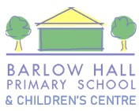
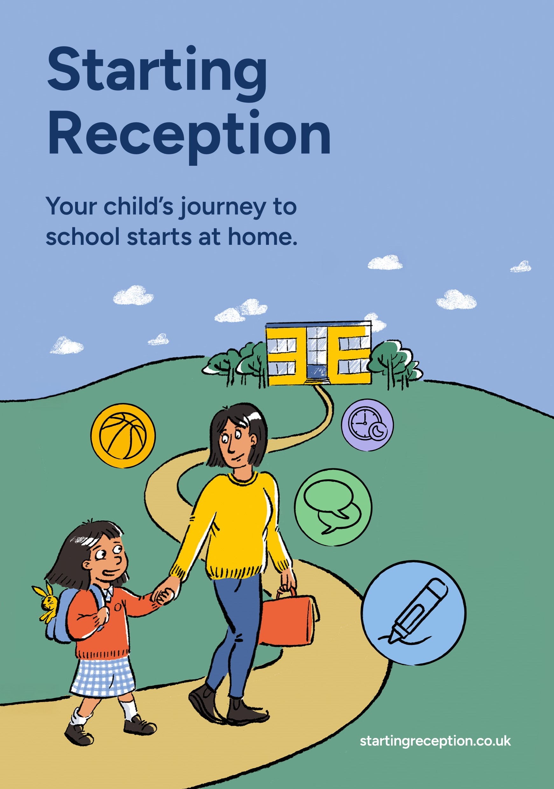
Introduction
We understand that all children develop at their own pace, and that we’re all learning from birth. When it’s time to start school, some children will need more help than others.
There are key skills* that schools expect children to be learning before their first day. Practising these will make your child’s journey to Reception as positive as possible.
If your child is already at nursery, in pre-school, or with a childminder, those professionals will work with you and your child to help get them ready.
There’s lots you can do at home to build your child’s confidence and independence, helping them feel emotionally and practically prepared to start school.
*We are calling this document the ‘Starting Reception’ definition. Some people/ organisations refer to this as ‘school readiness’.
How can I help my child get ready?
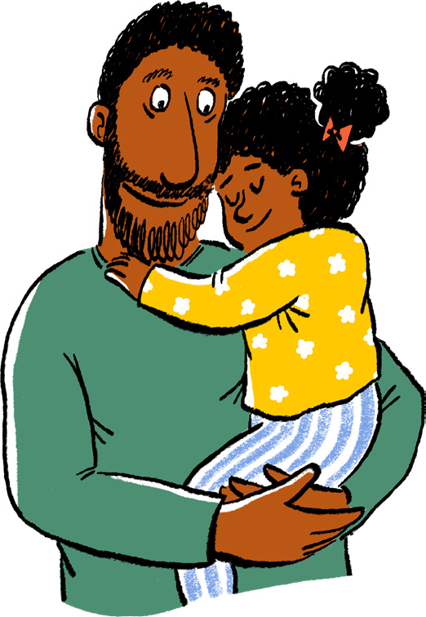
Your child will have lots of new activities and routines to get used to when they start school. There are some things they’ll need to do more independently than they might have before.
Research shows that a child’s relationship with their parents is the most important factor in their development, and there’s a lot you can do at home. When your child is at home with you or another caregiver, you can practise as a family with fun activities (we’ve included links at the end of this resource).
Some of these skills take time to master, so it’s good to introduce them gradually in your daily routine.
What if my child has additional needs?
- If your child needs additional support to settle into Reception, make sure you share as much information as possible with their new teacher. They can work with you to find strategies to support your child.
- Summer born children, or those speaking English as an additional language (EAL) may need more support.
- If you know or suspect your child has special educational needs (SEND), developmental differences or delays, some of these skills may not be achievable for them at this point.
- Early intervention makes a big difference – ask your child’s nursery, school, health visitor, local children’s centre or Family Hub for help.
Who can I speak to for help?
All children will need help from their trusted adults so they can feel confident and excited about starting Reception.
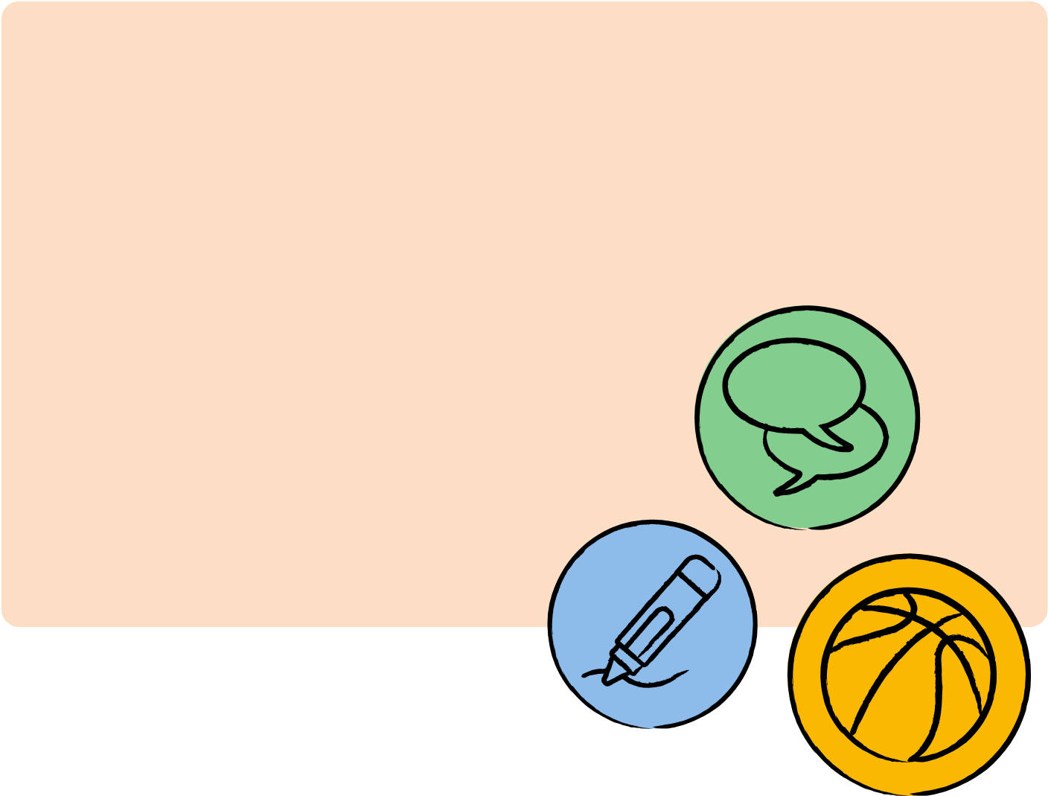
- Your childminder/nursery/pre-school team or your health visitor, children’s centre or family hub can help if you need more information.
- We’ve also put together a list of organisations and resources further down to help you and your child get ready together.
The definition: skills to practise before starting Reception:
New skills take time to learn. Practising at home will help your child move into school more easily and with confidence.
Growing independence
Taking care of themselves
Putting on/taking off their coat and shoes
Using the toilet and washing their hands
Getting dressed with little help, e.g. after using the toilet or doing PE
Using cutlery (e.g. fork and spoon, chopsticks) and drinking from an open cup
Spending time away from you, learning they can be looked after by caring adults
Play, creativity and curiosity
Taking part in imaginative play (e.g. role play)
Drawing, painting, colouring and sticking
Sharing story books, looking at pictures and talking about the characters
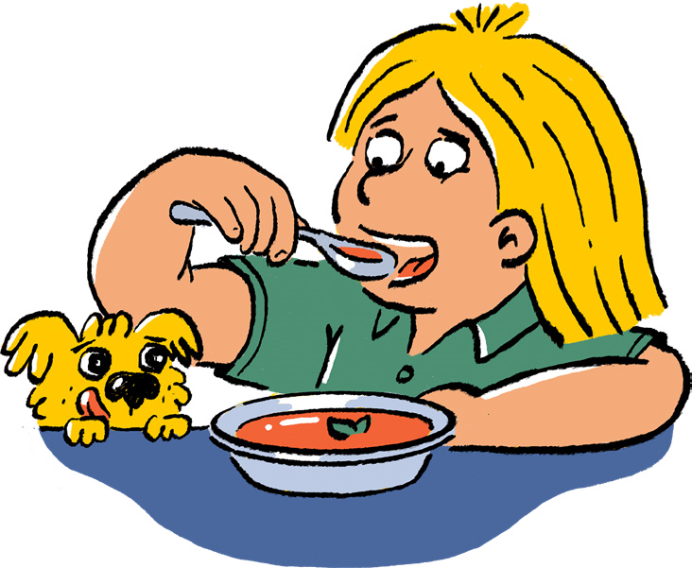
Exploring the world around them (e.g. looking closely at the natural world, playing safely with objects at home)
At school your child will be meeting lots of new people and make new friendships. Some things to help them get ready include:
Building relationships and communicating
Being with others
Practising sharing and taking turns with toys
Talking to them about how they are feeling and why

Looking at story books together and speaking about what characters are feeling is a good way to do this Beginning to recognise what others are feeling, e.g. understanding if a friend is sad
Encouraging them to set boundaries for themselves and others (e.g. knowing how to say ‘no’)
Communication and language
Singing along with songs and nursery rhymes
Talking happily to others about activities, experiences and the world around them
Showing they need help by speaking clearly
(in basic English or sign language)
Recognising the pattern of their name (so they can find it on their coat peg or jacket)
Listening and engaging
Paying attention for short periods of time
Listening to and following simple instructions
Carrying on with a task even when it’s difficult and bouncing back if things go wrong
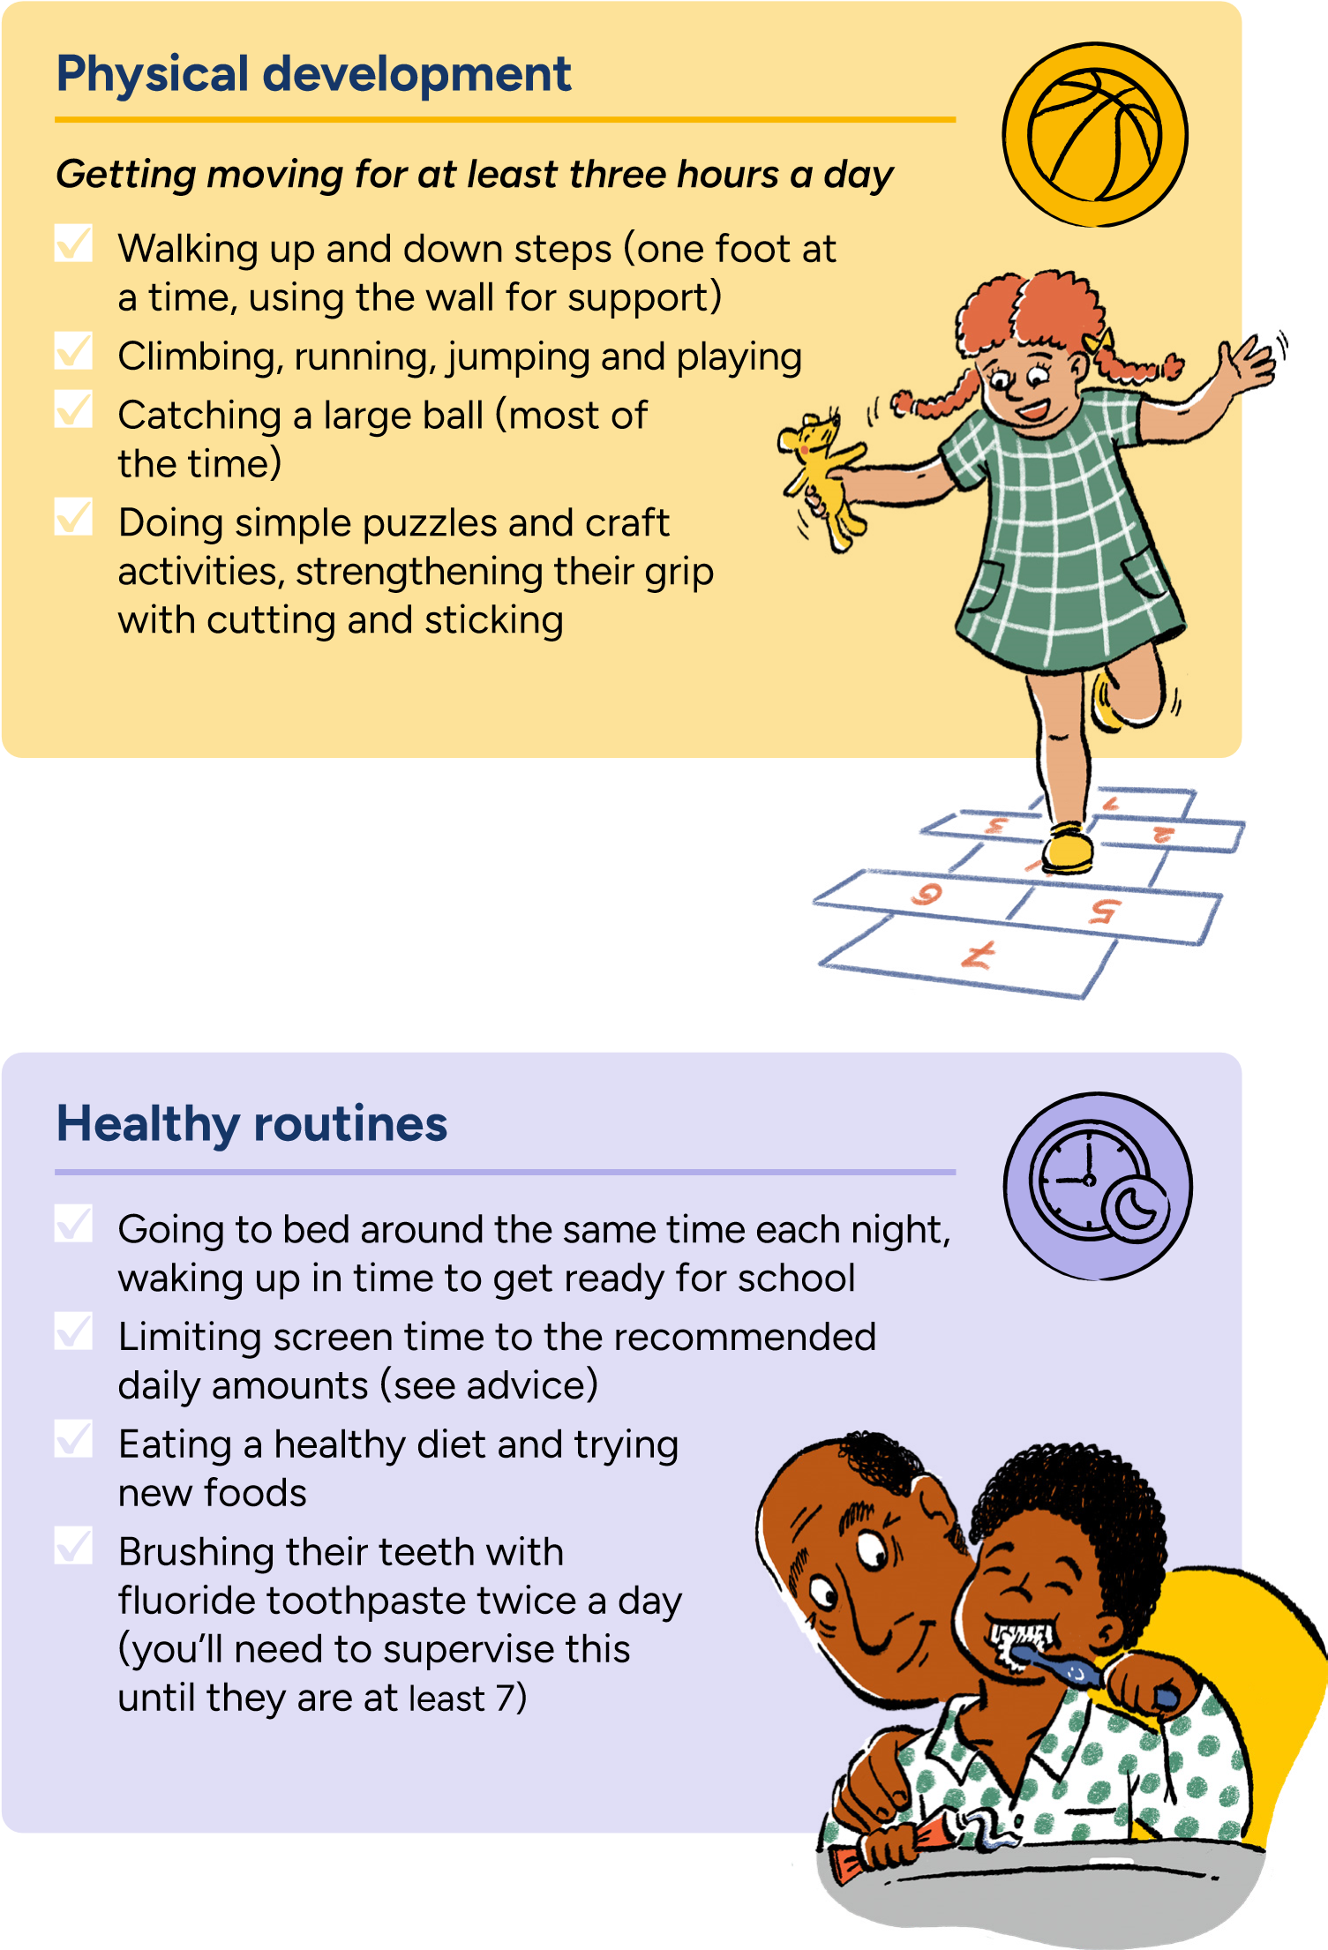
What should I do if I have concerns about my child’s development?
- If you’re worried about your child’s progress, talk to your childminder/nursery/pre-school team, health visitor, local children’s centre or Family Hub.
- If your child has developmental delays or SEND (suspected or confirmed), speak to their nursery, childminder, or health visitor/nursery/pre-school team well before they start Reception and discuss their needs when you are selecting schools.
- You can work with your child’s early years setting to help your child with self-care, managing emotions, social skills, and communication in a way that suits their stage of development.
- You might want to share details about their development, needs, what motivates them, what might trigger difficulties, how they learn best, and what strategies work well.
- Make sure you share important information with everyone supporting your child, including their new Reception teacher.
Resources for families with additional needs
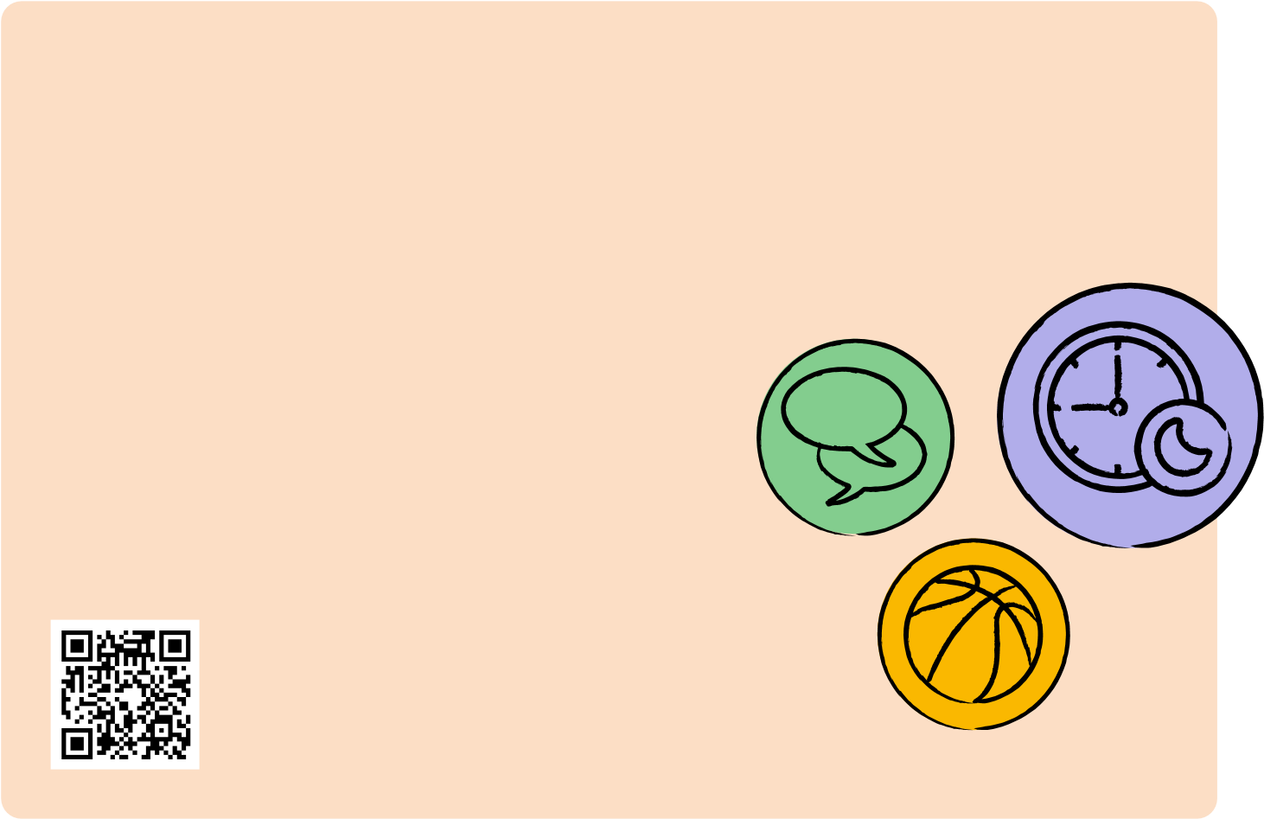
There are many organisations who can support with information and strategies to prepare you, your child and their educational setting, ensuring a smooth transition and setting them up for future success. These include:
- Family Lives
- Speech and Language UK
- Dingley’s Promise
- KIDS Find out more
For more information, visit https://startingreception.co.uk This definition was created collaboratively by
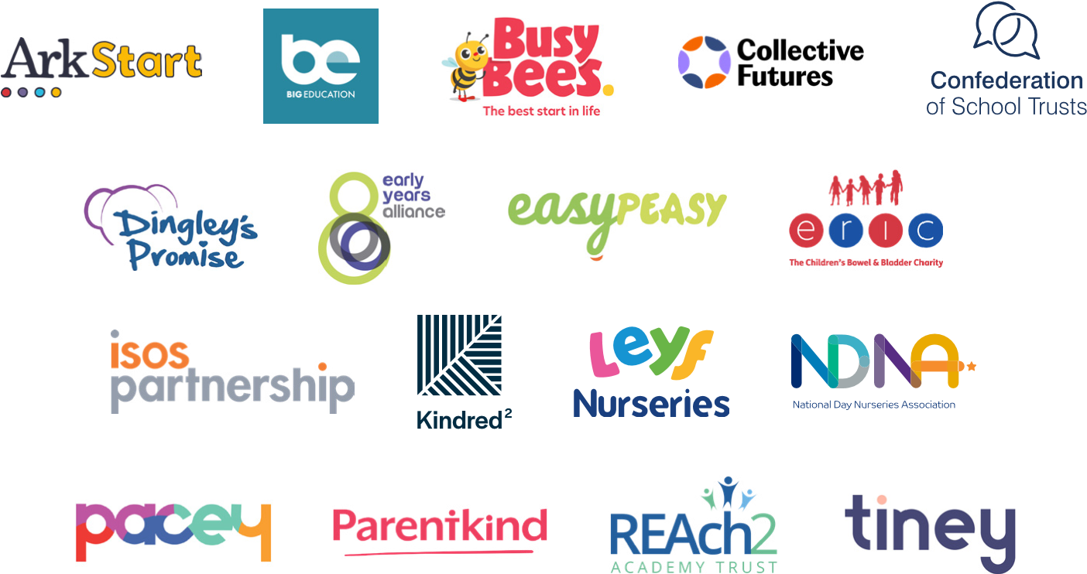
Notes:

