


Link Learning Trust
Barlow Hall Primary School

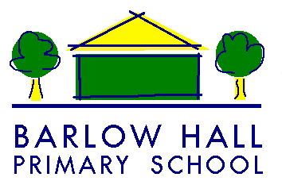

Visitor’s Guide to Barlow Hall
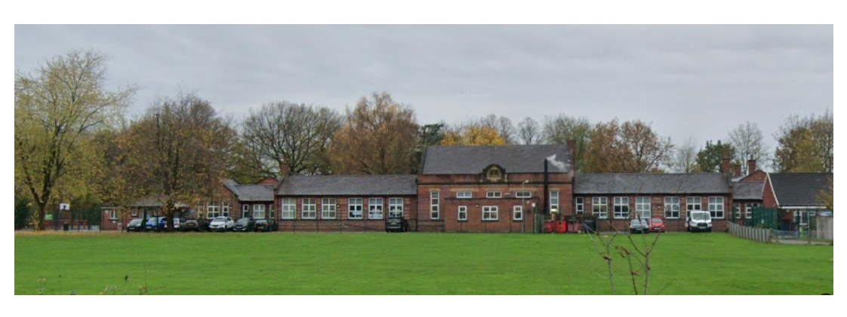

INFORMATION FOR VISITORS TO BARLOW HALL

Welcome from our Executive Head, Jayne Kennedy

We are delighted to welcome you to Barlow Hall Primary School, part of LINK Learning Trust. Our school is a caring, warm environment where staff do everything to support and care for our children. We have high expectations for ourselves and others. We provide a very inclusive, nurturing, safe and caring environment for our pupils.
We hope you enjoy your visit. As a Sandwell Wellbeing School we welcome any questions, comment or feedback.

It is our aim to:
Provide an inspirational experience that develops imaginative learners who take ownership of their learning, are proud of their achievements, and are prepared for a life in modern Britain
Our values are embedded through every layer of governance and drive everything we do.
We are:
- Child centric - children are our raison d’etre.
- Collaborative - we learn with and from each other.
- Creative - we are innovative and forward thinking.
- Responsive - we serve the needs of our communities.
- Passionate - about improving children’s life chances.
- Inclusive - we celebrate diversity and challenge prejudice and ignorance.
- Relentless - we are progress orientated, no child left behind.
- Excellence - we are driven by purpose - the pursuit of school improvement.
- Positive - we challenge fixed mindsets and promote growth mindsets.
On Arrival and Departure
Please sign in at Reception on arrival.
Lanyards will be issued to all visitors once they have signed in.
The visitors badge and lanyard must be worn and clearly visible at all times whilst on site and should be returned to office staff on departure.
Please read and follow the safeguarding information within in this booklet
When departing all visitors must sign out and return their badge and lanyard to our office team

- All visitors must follow school procedures whilst on the premises
- DBS and identity checks will be undertaken by the Admin Team if necessary
- Visitors will be met in Reception and escorted by a member of staff or designated Young Leader

Your safety and well-being during your visit are important to us.
As a visitor you have a legal duty to care for the health and safety of yourself and others.
Toilet Facilities: Staff and visitors toilets are available through the double doors to the office, and next door to the Nursery
Smoking: School operates a STRICTLY NO SMOKING/ NO E-CIGARETTES/NO VAPING POLICY

Personal Belongings: Barlow Hall Primary School accepts no responsibility for loss or damage to visitors’ property or vehicles.

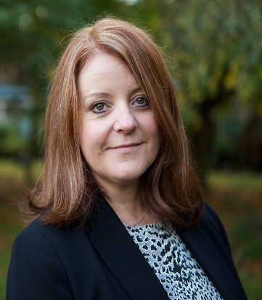
Safeguarding
Barlow Hall Primary school is committed to safeguarding and promoting the welfare of children and young people. We expect all adults in school to share this commitment. Staff and visitors are expected to demonstrate professional, personal behaviour and conduct. If you have any questions or queries please see one of our safeguarding leads.

- If you have any concern that a child has been harmed, may Jayne Kennedy be at risk of harm or a child makes a disclosure please discuss Executive Head with the member of staff who has arranged your visit and they will refer you to a member of the Safeguarding Team. The Designated Lead for Safeguarding is: Alice Corlett (Deputy Head)

- Please do not speak to any children on your visit unless this has already been authorised.

- The barrier at the end of the drive will be closed from 8:30-9:00 am/3:00–3:30 pm to ensure our children and families arrive and leave safely. Please respect this rule. Alice Corlett
As a visitor to our school we expect you to respect the Deputy Head confidentiality of our children and families
Tips for responding to safeguarding and child protection concerns:
- Stay Calm
- Do NOT guarantee confidentiality
- Reassure and be prepared to listen
- Do not ask leading questions
- Do not be a detective
- Record as soon as possible
- Keep your notes
- Report to one of the school’s Safeguarding Leads
- Follow the advice given

Mobile Phones, Cameras and Recording Devices

Please note Mobile phones, cameras or recording devices must not be used around the school building and photos must not be taken unless authorisation has been given by the Executive Head or Head of School

Health and Safety
- Hot drinks are only to be consumed in designated areas (staff room/ training room)
- As a visitor, you have a legal duty of care for the Health and Safety of yourself and others. Please inform the office or member of staff who has arranged your visit if you have any concerns.

Emergency Evacuation Procedures
This standard procedure is designed to inform visitors of the actions required in an emergency situation. All visitors are advised to make themselves familiar with our Fire/Emergency Evacuation Notices. These are clearly displayed around the school building.
Actions to be taken if you discover a fire:
- Alert another adult in the immediate vicinity
- Sound the alarm by breaking the glass of the nearest fire alarm call point (small red box)
- Leave the building as described below
Action to be taken if the FIRE/EMERGENCY ALARM SOUNDS IN THE BUILDING:
- Immediately stop what you are doing
- Evacuate the building through the nearest emergency door
- Make your way to the Emergency Assembly Point on the field at the front of school
- Do not attempt to re-enter the building until you have been authorised to do so.

We hope you enjoy your visit and thank you for supporting us in making sure Barlow Hall is a safe environment for all.

Executive Head: Jayne Kennedy
Barlow Hall Primary School, Darley Avenue, Chorlton, Manchester, M21 7JG
Telephone: 0161 881 2158
Email: admin@barlowhallprimary.co.uk
www.barlowhallprimary.co.uk

