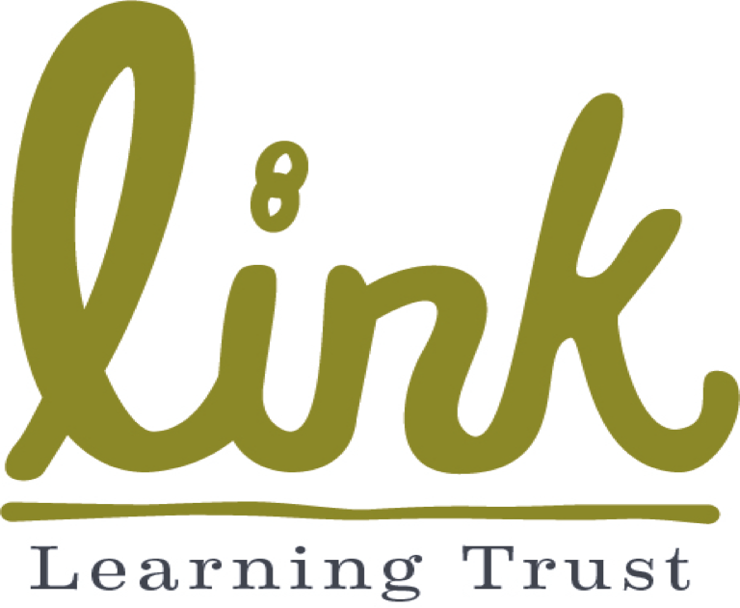
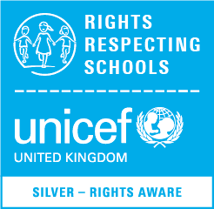
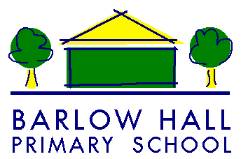

Link Learning Trust Barlow Hall Primary School
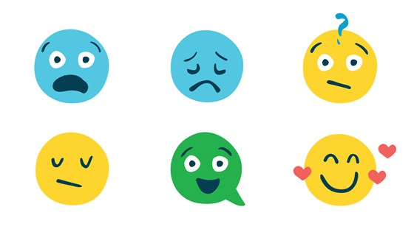
‘Keeping you safe’

You have a right to be safe, wherever you are.
Article 19

What is child protection about?
At Barlow Hall Primary School, all of the adults around you think that your health, safety and wellbeing are very important. In our school we respect our children and want to keep you safe and help to protect your rights as set out in the UN Convention on the Rights of the Child.
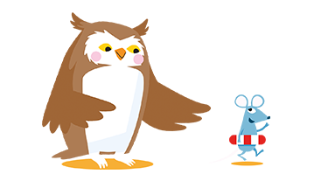
How will adults keep you safe?
- Make sure everywhere in school is safe. This includes your classroom, the corridors, the playground and playground equipment.
- Teach you how to stay safe, at home as well as at school
- Make sure you know where to get help if you are worried or unhappy about something
- Listen to you, respect what you say and take what you say seriously
- Make time if you need to talk
- Have a worry box in each classroom so you can let adults know if you are worried
- Use the LEAF to help solve any problems
- Mrs Holden’s most important job in the school is to make sure that you are safe and you have the right support in place to help you. Sometimes she might have to come and speak to you to check you are safe and ok.

What should you do?
- Speak to a trusted adult if you are worried about something in school or at home. If you can’t speak to someone, put a note in the worry box and someone who knows you well will get back to you.
- Be careful about how you play with each other- remember ‘everyone has the right to play and relax’
- Think about what you say to each other and how this might make someone else feel.
- If you think someone is being mean to you or you are being bullied speak to a trusted adult. A friend might help you to do this.
- If you think you are being bullied online at home, don’t keep it a secret- tell someone. Learn how to take a screenshot on your device.
- If a child or grown-up says something to you, or you hear something that you do not like or that upsets you, you must tell your parent/carer, a teacher or someone you can trust.
- Your body belongs to you and not to anyone else. This means all of your body. If someone touches you on a part of your body that is private or anywhere that you do not like, it is not ok. You must tell your parents/ carers, a teacher or someone you can trust as soon as you can.
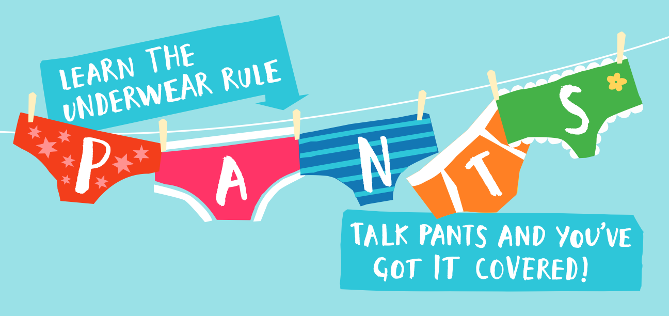
- If a student or a grown up hits you, punches you, pinches you or hurts you in anyway, you must tell your parents/carers, teacher or someone you can trust as soon as you can.
- Secrets such as a surprise parties are fun, but if someone asks you to keep a secret that makes you feel uncomfortable, you think it is wrong or it upsets you, talk about it with someone you trust.
- Presents are a good thing to get, but you shouldn’t take presents from anyone without checking with your parents/ carers first. Most of the time it is ok but sometimes people try and trick children into doing something by giving them presents like sweets, money and phones. This is sometimes called a bribe. If someone is trying to give you things without your parents/ carers knowing, you must let them or a trusted adult know.

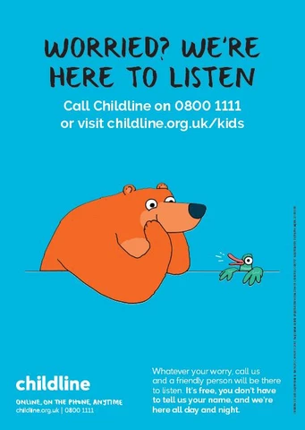

All the adults around you are ‘Duty Bearers’. Duty Bearers have a particular responsibility to respect and promote your rights. At Barlow Hall everyone has the responsibility to keep you safe.

