Pupil premium strategy statement – Barlow Hall Primary School (25/26)

This statement details our school’s use of pupil premium funding for the academic year 2025 to 2026 to help improve the attainment of our disadvantaged pupils.
It outlines our pupil premium strategy, how we intend to spend the funding in this academic year and the outcomes for disadvantaged pupils last academic year.

School overview
Detail | Data
Number of pupils in school | 220
Proportion (%) of pupil premium eligible pupils | 60.5%
Academic year/years that our current pupil premium strategy plan covers (3-year plans are recommended – you must still publish an updated statement each academic year) | 23/24  24/25  25/26
Date this statement was published | December 2025
Date on which it will be reviewed | October 2026
Statement authorised by | Alice Corlett
Pupil premium lead | Alice Corlett
Governor / Trustee lead | Matthew Williams

Funding overview
Detail | Amount
Pupil premium funding allocation this academic year | £182,101
Pupil premium funding carried forward from previous years (enter £0 if not applicable) | £0
Total budget for this academic year  If your school is an academy in a trust that pools this funding, state the amount available to your school this academic year | £182,101

Part A: Pupil premium strategy plan

Statement of intent
Some of our disadvantaged pupils need specific additional support following a needs analysis in order to enjoy and succeed academically ensuring they achieve well and make good progress from their starting points.
High quality first teaching is at the heart of our approach. The strategies outlined support both disadvantaged and non-disadvantaged pupils at Barlow Hall.
Our current strategy focuses on:
• Developing oral language skills and extending the vocabulary that our children use.
• Supporting school readiness for children joining our early Years whether at Barlow Bears (two year old provision), nursery or reception cohorts.
• Developing strategies for children to support their concentration and metacognition
• Using researched intervention.
• Developing strategies for children to support self-regulation.
• Supporting attendance for all children.
Our key principles of our pupil premium strategy are:
• Early identification and intervention.
• A shared responsibility for outcomes across the whole staff team
• Increase the number of disadvantaged children achieving combined (reading, writing and maths) expected levels at the end of each phase in school, Early Years, KS1 and KS2.
• Clearly researched and evidenced strategies:
➢ “Teacher Feedback to Improve Learning. “ (EEF)
➢ “Improving Literacy in KS1 and KS2” (EEF)
➢ “Preparing for Literacy.” (EEF)
➢ “Metacognition and Self-Regulated Learning.” (EEF)
➢ “Improving Behaviour in Schools.” (EEF)
➢ “Improving Mathematics in Early Years, KS1 and KS2”
➢ “Putting Evidence to Work – A School’s Guide to Implementation.” (EEF)

Challenges
This details the key challenges to achievement that we have identified among our disadvantaged pupils.
Challenge number | Detail of challenge
1 | Poor oral language skills and limited vocabulary, which will lead to lower outcomes in reading, writing and self-regulation
2 | Mathematical understanding and application of number and fluent recall of number facts
3 | School readiness in Early Years including: Listening, attention and understanding, speaking, self-regulation as well as word reading, writing and number
4 | A range of additional needs that impact on children’s concentration, metacognition and self-regulated learning in school.
5 | Low attendance, poor punctuality and parental engagement for some disadvantaged families

Intended outcomes
This explains the outcomes we are aiming for by the end of our current strategy plan, and how we will measure whether they have been achieved.
Intended outcome | Success criteria
Improved language and vocabulary | Formative assessments, lesson observation and pupil voice activity demonstrate improved oral language, which are impacting on better reading and writing outcomes.
Better mathematics outcomes for disadvantaged learners. | Improved GLD, reading and writing at KS1 and KS2. The gap closed for disadvantaged pupils when compared to autumn assessments.
Improved school readiness for children in Barlow Bears, Nursery and reception. | Improved Wellcomm scores (language assessment) for early Years children with fewer children scoring ‘red.’ Children’s development, as evidenced by the on-line Learning Journey, Tapestry, demonstrates good progress from starting points. Completion of Early Help Assessments
Children’s independence, both academically and in their behaviours for learning improves. Children self-regulate well. | Lesson observation, pupil voice, book scrutiny demonstrate that disadvantaged children are accessing prior learning, engaging with teacher modelling and scaffolding in order to independently apply during learning, resulting in better academic outcomes
Improved punctuality and attendance for target disadvantaged learners. | Attendance continues to improve with the gap between non-disadvantaged peers closing with the disadvantaged group. Attendance remains, at least, in-line with national expectations. Fewer persistent absent children.
Improved academic outcomes for the disadvantaged target group. | Measured accelerated progress from autumn term baseline measures. Children at least in-line with national averages by the end of KS1 and KS2. By the end of reception children have made accelerated progress from their baseline. The gap with national averages is closing and no more than 15% for disadvantaged learners. Accelerated progress for children receiving tutoring.

Activity in this academic year
This details how we intend to spend our pupil premium funding this academic year to address the challenges listed above.

Teaching (for example, CPD, recruitment and retention)
Budgeted cost: £ 35,988
Activity | Evidence that supports this approach | Challenge number(s) addressed
SENCo to support CPD and specialist knowledge for mainstream teachers to ensure all pupils can access the best teaching. | Pupils with Special Educational Needs and Disability (SEND) have the greatest need for excellent teaching and are entitled to provision that supports achievement at, and enjoyment of, school. The attainment gap between pupils with SEND and their peers is twice as big as the gap between pupils eligible for free schools meals and their peers. However, pupils with SEND are also more than twice as likely to be eligible for free school meals.  https://educationendowmentfoundation.org.uk/education-evidence/guidance-reports/send | 1, 3, 6
Implementation of an Oracy curriculum and access to staff CPD via Voice 21 Development and Consultancy Days | Voice 21 uses an oracy-focused approach to boost outcomes for Pupil Premium children, helping them build confidence, improve engagement, and raise attainment. https://voice21.org/  https://educationendowmentfoundation.org.uk/education-evidence/teaching-learning-toolkit/oral-language-interventions | 1, 6
Reducing the staff to pupil ratios in Early Years by employing additional support staff in Barlow Bears, nursery and reception. This will enable us to deliver better and more frequent communication and language approaches. | Ratios reduced in nursery. Additional support in Barlow Bears.  This approach enables better prioritisation of development of communication and language and embeds opportunities to develop self-regulation. Staff will continue to receive professional development to support phase improvements, in conjunction with professional support from Speech and Language therapist and Occupational Therapist. This will be measured by external QA termly.  https://educationendowmentfoundation.org.uk/education-evidence/guidance-reports/literacy-early-years  This approach will also support our approaches to school readiness. | 1, 2, 3
Improve outcomes for disadvantaged pupils in Reception and Year 1 writing through EEF project The Write Beginnings | Barlow Hall participates in The Write Beginnings in conjunction with the EEF and Manchester Research School, focus on improving writing outcomes for disadvantaged pupils in Reception and Year 1.  Release time for staff and senior leaders to attend development days, cluster meetings and develop implementation plan to disseminate CPD to all teaching staff to impact wider cohort of our disadvantaged pupils across other year groups. | 1, 6

Targeted academic support (for example, tutoring, one-to-one support, structured interventions)
Budgeted cost: £17,355
Activity | Evidence that supports this approach | Challenge number(s) addressed
TA intervention small group  EEF research individualised instruction +4 | Tutoring and small group is one of the most effective tools for disadvantaged and vulnerable pupils to make accelerated progress. This is likely linked to pupils receiving more feedback, being more engaged and completing work tailored to their specific needs. Tutoring can also help pupils to build resilience. Research by the Education Endowment Foundation (EEF) and National Foundation for Educational Research shows that individual tuition builds pupils’ confidence and provides opportunities for staff to identify areas requiring specialist support. Many pupils find that tutoring offers a safe space to talk about concepts they have struggled with in the classroom.  https://educationendowmentfoundation.org.uk/education-evidence/teaching-learningtoolkit/small-group-tuition https://www.nfer.ac.uk/media/1700/eftr05.pdf | 1, 6
Inference Tutor group for children in Y4, 5 and 6.  EEF research reading comprehension strategies +6 |  | 1, 6

Wider strategies (for example, related to attendance, behaviour, wellbeing)
Budgeted cost: £135,720
Activity | Evidence that supports this approach | Challenge number(s) addressed
Two full time Learning Mentors who deliver the strategies that remove barriers to learning including: Social and emotional behavioural approaches and Self-regulation. The effective use of Barlow Hall’s LM interventions, alongside good teaching has been powerful ways to raise pupil attainment.  EEF research Social and emotional learning +4  Metacognition and self regulation +7 | Our Learning Mentors complement the focus and activities of other staff by developing intervention supporting learning behaviours that support effective learning in a group and classroom setting.  EEF guidance has supported Barlow Hall’s approaches, in particular:  • Improving Behaviour guidance  • Metacognition and self-regulated learning  • Special educational needs in mainstream schools  • Working with parents and  • Social and emotional learning | 3, 4
Work of the PSA to provide practical strategies to support learning and offer more sustained and intensive support where needed. Co-ordination of Early Help Assessment through the Inclusion Team, led by the Deputy Head who leads, monitors and trains on strength based conversations for staff undertaking EHAs.  EEF research Parental engagement +4 | Parents’ interest and involvement in their children’s learning is consistently associated with positive outcomes for children of all age groups but it can be challenging for schools to influence this effectively. The evidence for what schools can do to effectively engage parents in a way that improves children’s learning outcomes is limited, particularly for older children. Therefore, schools should be optimistic about the potential of parental engagement, but cautious about the best approaches — reviewing and monitoring their activities to check that they are having their intended impacts. Barlow Hall uses the EEF guidance document to support our approaches.  https://educationendowmentfoundation.org.uk/education-evidence/guidancereports/supporting-parents | 1, 4, 5
Barlow Hall being a partner with the Local Authority delivering the commissioned service by leading the Sure Start Children’s Centre and delivering on the Sure Start Core purpose. This enable Barlow Hall develop parental engagement and an earlier starting age to school.  EEF research Communication and language approaches +6 Earlier starting age +6  Self regulation strategies +5 | Better levels of parental engagement are consistently associated with better academic outcomes. Working with 0-5 s develops family language interests and modelling effective language and communication will support parents to understand how to help their child learn. More sustained and intensive strength based support where needed will be used to improve parental engagement and school readiness.  https://educationendowmentfoundation.org.uk/education-evidence/guidancereports/literacy-early-years  https://educationendowmentfoundation.org.uk/education-evidence/guidancereports/supporting-parents | 1, 3

Total budgeted cost: £189,063

Part B: Review of the previous academic year (24/25)

Outcomes for disadvantaged pupils
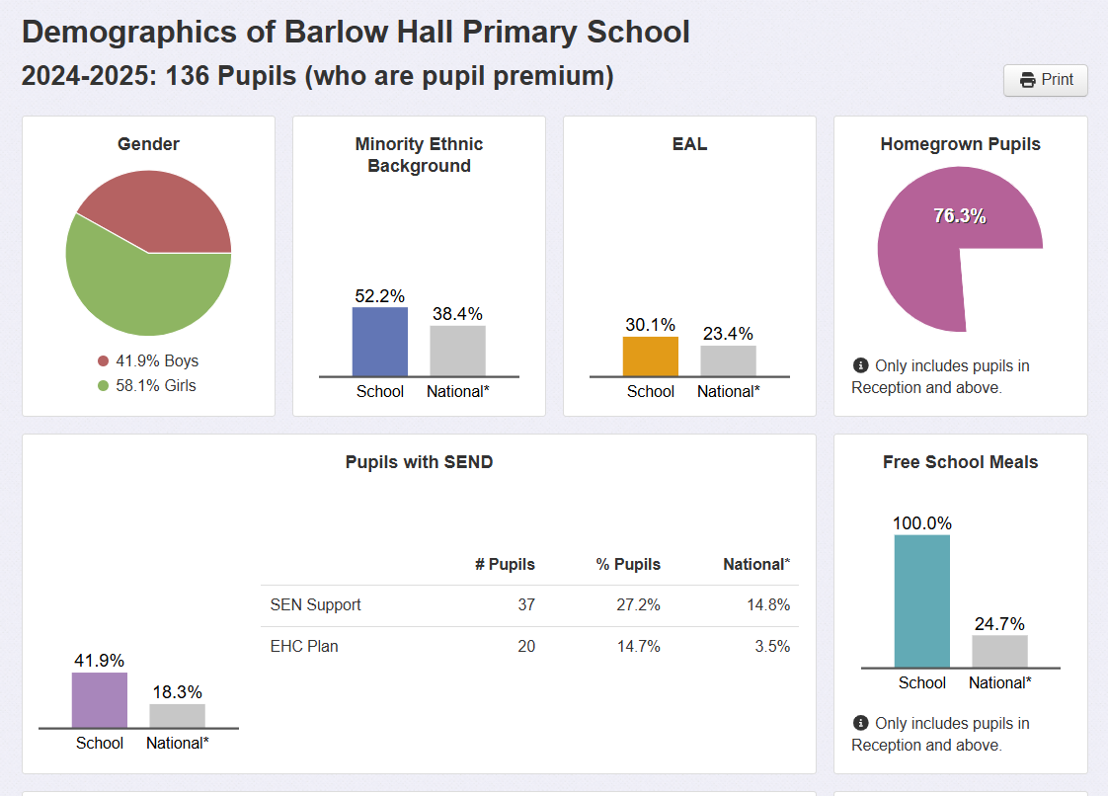

Attendance
24/25 disadv absence 5.5%, PA 10.6%
Good Level of Development/Early Years
Disadv pupils- 64% of cohort, Disadv GLD - 64.3% (School GLD – 58.3%)
WellComm screens demonstrate good progress - Of the 19 children in BH since Nursery 37% scored Green on their age appropriate WellComm screen on entry to Nursery and 79% scored Green at the end of Nursery
Disadvantaged pupils - 16 pupils 64% of the cohort
The disadvantaged pupils achieved 64.3% GLD, compared to non disadv 55.6%.

3 of the 8 SEND children are also disadvantaged.

The curriculum and the provision is equally ambitious for all pupils and this is evident in the previous visits to EYFS and discussions with leaders and EY2P QA visits. The phonics programme Sounds-Write supports all pupils and the school are part of the Think Equal programme.

Phonics
65.4% of the cohort were disadvantaged.
Year 1 | Disadvantaged
63% | 55.6%

KS1
 | ARE | Dis
Combined | 32% | 17%
Reading | 68% | 67%
Writing | 37% | 25%
Maths | 73% | 58%

KS2
19 children were disadvantaged, 61% of the cohort.
 | ARE | Dis
Combined | 77% | 79%
Reading | 90% | 95%
Writing | 80% | 84%
Maths | 87% | 84%

Disadv pupils outperformed peers in Reading and Writing, 3% difference in Maths outcomes at ARE

